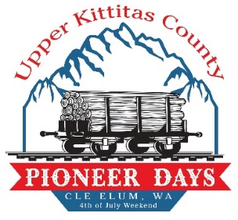
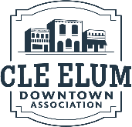
2026 Pioneer Days Planning Meeting
February 16, 2025
CEDA Office/Online Zoom
117 W First St.
10:00AM – 11:30AM

Introduction(s)
In-Person:
- Kaylee Thompson-CEDA; Executive Assistant
- Maggie Bator-CEVFFA
- Tatum Buechle-Community Member, Friends of the Library
- Amy Pridemore-Carpenter Memorial Library
- Michael Richard-CEDA President, Promotions Committee
- DeAnna Hamm-Pioneer Coffee, Promotions Committee
- Lori Nevin-Director UKCSC
- Dave Craft-Shaka Sound
Important Deadlines
- Event Permits (City of Cle Elum) – April 1, 2026 (May 1, 2026 is absolute deadline for applications)
- About 2 months to meet initial deadline
- If events are submitted after the deadline, you may be subject to pay a late fee (they are listed on event packets; $75 fee if turned in a month before)
- Marketing Deadlines:
  - Print Materials (CEDA) – May 22, 2026
  - Social Media (CEDA) – June 5, 2026

  - Newspaper Pioneer Day insert (Tribune) – Monday, June 22, 2026
  - Weekly Newspaper (Tribune) – Monday 12:00PM before distribution on Thursday
Please contact the NKC Tribune for more information 509-674-2511
Theme – Celebrating America’s 250th – Pioneer Days Weekend (Unconfirmed Event Covers)
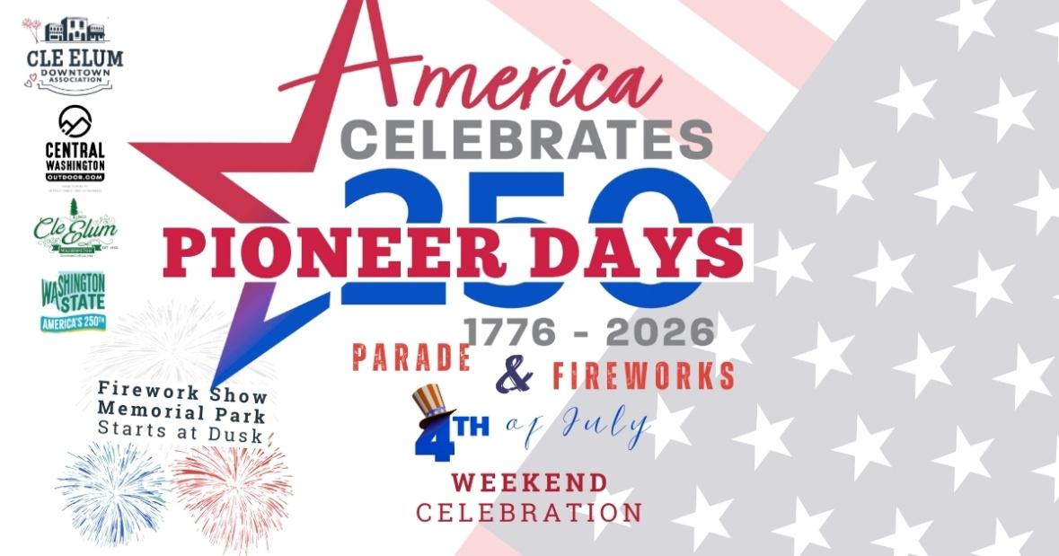
- Maggie suggested making Pioneer Days letters larger and moving the extra text over to the right and enlarging the logos a bit and the Firework show to be more visible
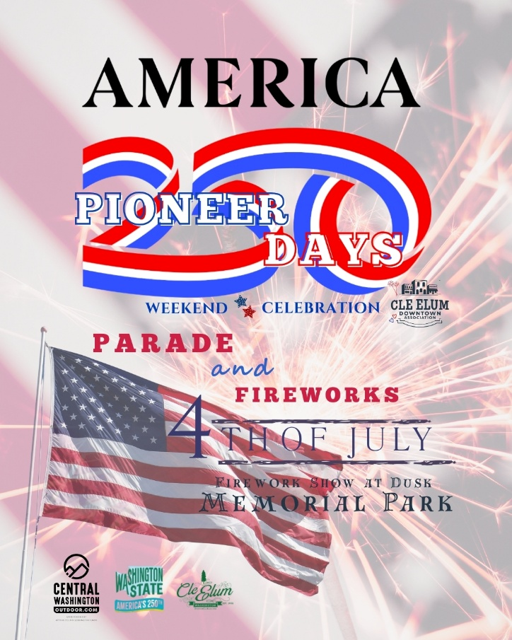
- Maggie suggested moving the Pioneer Days lettering above and below the America 250 logo to make the text more visible
- May need to adjust the 4th of July and Memorial park text and the flag in bottom left corner (or fade out)
CEDA submitted the Pioneer Days Weekend cover through the America250wa.org for extra free digital material online
Events
(Including details of dates, times, and what the sub-events are)
- Parade (CEDA) – Confirmed –(Need to confirm if we like event covers) (Need to make Dock Diving Dogs cover to include the America 250 logo)
- Dock Diving Dogs (CEDA) – Confirmed (Will there be a street fair or car show along East RR and Wye Park or in the Kuney yard?) –need to reach out to Darci Kelts and James Easterling. If the car show is along Wye Park, Fire Depts. And Medic One will be along grass/hillside of Wye Park.
- Fireworks (CEDA) – Confirmed (CEDA will be bidding out for the firework show this year) –will touch base with Jordan on this
- Fireman’s Pioneer Breakfast (CEFD Association) – Unconfirmed/Confirmed (need to find sponsors and print new material for this event)
- Theater Production (Boulet Theater) – Unconfirmed (Lori reminded us that Boulet will run the week after PD Weekend)
- Pioneer Day Queen Coronation - Unconfirmed
- Roslyn Riders Family Fun Play Day (Roslyn Riders) - Unconfirmed
- “Boss of the Toss” Cornhole Classic (Jerred Weis) - Unconfirmed
- 3-on-3 Basketball (Beau Nicholls) – Unconfirmed (3-on-3 group organizers may have changed)
- Rainier Revival (Mike’s Tavern) - Unconfirmed
- Street Fair & Fundraiser (Cle Elum Eagles) - Unconfirmed
- 9-hole Putt-Putt Golf (Dru Bru) - Unconfirmed
- Friends of the Carpenter Library Book Sale (Carpenter Library) - Unconfirmed
- Jam Shop Market (Vaughn Smith) – Unconfirmed

- Touch-a-Fire Truck (Miner’s?) – Unconfirmed (Ashley Evans and Jon Cornelius-need to talk with them)
- Touch-a-Truck: Military Vehicle (Jim Hanson) – Unconfirmed
- CEVFFA: Association Fundraiser – Unconfirmed
- Darci Kelts Suncadia –
- James Easterling – Car show – Unconfirmed
- Jensen Farms Outpost Kettle corn – Unconfirmed (Reached out to Hilary for kettle corn along Wye Park during firework show)
Comments/Questions/Concerns
- Tatum mentioned that Bev Gonyea leaves on March 1st for a couple weeks to see family, so may not be available for help
- Red cross, Medic One, and Fire Depts. Will fall under CEVFFA’s liability insurance and will be hosted by the Cle Elum Fire Association
  - This does not cover bounce houses, dunk tanks, or higher liability event(s)
- Amy from Carpenter Memorial Library & c/o Friends of the library –will have a book fair on July 4th and a scavenger hunt that is part of the SRP that the library does as a summer series of events
- There are suggestions made for Kuney yard, IFO CEFD, or along WaFd/Farm & Home; Pennsylvania Ave. for the Touch-a-Truck event with Miner’s Pizza Food Truck?
- CEDA will reach out to Jon, Cassidy, and Ashley about more details/suggestions
- Lori said to reach out to Dawn with the Teen Shop Community Builders for a sidewalk sale
- CEDA will add the event cover(s) and the Pancake Breakfast event cover in this for everyone to look over
- Event packets need to be done completely and turned in by NO LATER than May 1, 2026, these need to include road closures/Right of Way permits (if needed)
- Do we like the “Celebrating America’s 250 -Pioneer Days Weekend, Cle Elum” or “America Celebrates 250 -Pioneer Days Weekend, Cle Elum”
- Is James hosting a car show along RR street? Or will CEVFFA have a street fair in place of?
- CEVFFA will be giving out glowsticks (by donation) for these during firework show
- We NEED photos of Wye Park filled with people during firework show and along RR Street that highlights how many people are spectating
- Dave Craft shared information about 11 ft. speakers projecting sound during parade (will have 1 technician all throughout), we will need 2 announcers again –same as Christmas in Cle Elum parade set-up
- In help of parade, fireworks, dock dogs (make a post online/website to see who can help with what specific tasks throughout the day)
- Don’t want all the work to fall on only a small group of people
- Generalized post/website add-on of spots assigned for what volunteers are needed
- Lori offered to seek out 2-3 volunteers to help after the parade –Michael suggested to find more volunteers
- Dave asked about canned waters –CEDA will partner with DruBru again and have 2-3 water sponsors again
  - CEDA will give some to CEVFFA as they sponsor so they can be handed out during the street fair, will be held in coolers
  - Remind Maggie that advertising as a fire, EMS, and Red Cross street fair will get more folks around Wye Park
  - CEDA will provide a flat or 2 of waters to Dock Diving Dogs hosts for hydration too
- Summer Reading Program; Scavenger hunt all throughout PD Weekend
- Learning about dinosaurs and skulls will be along downtown businesses
- Suggest Cle Elum City Park for touch-a-truck event so that it doesn’t exactly interfere with fire dept. and associations fundraising??
- CEDA will reach out accordingly with all updates and Confirmed/Unconfirmed Events
- If you need assistance with event packets or details, please reach out, the packets have some changes in them
- Need to confirm porta-potties and sound systems with Chad and Dave
- DeAnna mentioned that getting all information out there and encouraging more voices, posts, and sidewalk sales will really benefit the celebration of 250 years for PD
- CEDA mentioned doing a mock post of the one similar to Valentine’s Day and writing out all the events in smaller blurbs to help push out the information more
- More eyes and comments on posts is better
- All print material will continue to push/boost the events and sub-events
- Lori/Dave asked if we have reached out to other businesses for sidewalk sales or getting more people around Wye Park and not directly downtown
- CEDA mentioned getting Jensen Farms Kettle Corn involved at Wye Park

Meeting end: 11:24 AM
Next Meeting Monday, March 16, 2026, 10:00AM – 11:30AM

